Supplementary material

Combinatorial modular pathway engineering for guanosine 5′-diphosphate-L-fucose production in recombinant Escherichia coli
Li Wan ¹, Yingying Zhu ¹, Wen Li ¹, Wenli Zhang ¹, Wanmeng Mu ^{1,2,*}

¹ State Key Laboratory of Food Science and Technology, Jiangnan University, Wuxi, Jiangsu, 214122, China.
² International Joint Laboratory on Food Safety, Jiangnan University, Wuxi 214122, China.

* Corresponding author: wmmu@jiangnan.edu.cn

Table S1 Strains used in this study.
Strains | Relevant genotype and description | References
E. coli DH5α | F⁻ endA1 glnV44 thi-1 recA1 relA1 gyrA96 deoR nupG Φ80dlacZΔM15 Δ(lacZYA-argF) U169, hsdR17 (r_{K}⁻ m_{K}⁺), λ– | Type strain
E. coli BL21 (DE3) | F⁻ompT hsdSB (r_{B}⁻ m_{B}⁻) gal dcm rne131 λ (DE3) | Type strain
BL21 (ΔwcaJ) | E. coli BL21 (DE3): ΔwcaJ | This study
EWL01 | E. coli BL21 (DE3) harboring plasmid pET-gmd-wcaG | This study
EWL02 | EWL01 harboring plasmid pCDF-manC-manB | This study
EWL03 | EWL01 harboring plasmid pACYC-manC-manB | This study
EWL04 | E. coli BL21 (DE3) harboring plasmid pCDF-gmd-wcaG | This study
EWL05 | EWL04 harboring plasmid pET-manC-manB | This study
EWL06 | EWL04 harboring plasmid pACYC-manC-manB | This study
EWL07 | E. coli BL21 (DE3) harboring plasmid pACYC-gmd-wcaG | This study
EWL08 | EWL07 harboring plasmid pET-manC-manB | This study
EWL09 | EWL07 harboring plasmid pCDF-manC-manB | This study
EWL11 | E. coli BL21 (DE3) harboring plasmids pACYC-[RBS-WT]-C-[RBS-WT]-B and pET-[RBS-WT]-G-[RBS-WT]-W | This study
EWL12 | E. coli BL21 (DE3) harboring plasmids pACYC-[RBS-WT]-C-[RBS-WT]-B and pET-gmd-wcaG | This study
EWL13 | E. coli BL21 (DE3) harboring plasmids pACYC-[RBS-WT]-C-[RBS-WT]-B and pET-[RBS-32]-G-[RBS-32]-W | This study
EWL21 | E. coli BL21 (DE3) harboring plasmids pACYC-manC-manB and pET-[RBS-WT]-G-[RBS-WT]-W | This study
EWL23 | E. coli BL21 (DE3) harboring plasmids pACYC-manC-manB and pET-[RBS-32]-G-[RBS-32]-W | This study
EWL31 | E. coli BL21 (DE3) harboring plasmids pACYC-[RBS-32]-C-[RBS-32]-B and pET-[RBS-WT]-G-[RBS-WT]-W | This study
EWL32 | E. coli BL21 (DE3) harboring plasmids pACYC-[RBS-32]-C-[RBS-32]-B and pET-gmd-wcaG | This study
EWL33 | E. coli BL21 (DE3) harboring plasmids pACYC-[RBS-32]-C-[RBS-32]-B and pET-[RBS-32]-G-[RBS-32]-W | This study
EWL34 | EWL13 derivate, ΔwcaJ | This study
EWL35 | EWL34 harboring plasmid pCDF-zwf | This study
EWL36 | EWL34 harboring plasmid pCDF-gsk | This study
EWL37 | EWL34 harboring plasmid pCDF-gsk-zwf | This study

Table S2 Plasmids used in this study.
Plasmids | Relevant properties or genotype | Source or references
pETDuet-1 | Double T7 promoters with two MCS, pBR322 replicon (copy number ~40), lacI gene, Amp^{R} | Novagen
pCDFDuet-1 | Double T7 promoters with two MCS, CDF13 replicon (copy number ~20), lacI gene, Sm^{R} | Novagen
pACYCDuet-1 | Double T7 promoters with two MCS, P15A replicon (copy number ~10), lacI gene, Cm^{R} | Novagen
pCas | RepA101(Ts), Kan^{R}, P_{cas}–cas9, P_{araB}-Red, lacI^{q} P_{trc}-sgRNA-pMB1 | (Jiang et al., 2015)
pTargetF | sgRNA plasmid, pMB1 ori, Spe^{R} | (Jiang et al., 2015)
pET-manC-manB | pETDuet-1 carrying manC and manB from E. coli MG1655 | This study
pET-gmd-wcaG | pETDuet-1 carrying gmd and wcaG from E. coli MG1655 | This study
pCDF-manC-manB | pCDFDuet-1 carrying manC and manB from E. coli MG1655 | This study
pCDF-gmd-wcaG | pCDFDuet-1 carrying gmd and wcaG from E. coli MG1655 | This study
pCDF-zwf | pCDFDuet-1 carrying zwf from E. coli MG1655 | This study
pCDF-gsk | pCDFDuet-1 carrying gsk from E. coli MG1655 | This study
pCDF-gsk-zwf | pCDFDuet-1 carrying gsk and zwf from E. coli MG1655 | This study
pACYC-manC-manB | pACYCDuet-1 carrying manC and manB from E. coli MG1655 | This study
pACYC-gmd-wcaG | pACYCDuet-1 carrying gmd and wcaG from E. coli MG1655 | This study
pET-[RBS-32]-G-[RBS-32]-W | pETDuet-1 carrying gmd and wcaG under the control of RBS-32 | This study
pET-[RBS-WT]-G-[RBS-WT]-W | pETDuet-1 carrying gmd and wcaG under the control of the wild type RBS of gmd and wcaG, respectively | This study
pACYC-[RBS-32]-C-[RBS-32]-B | pACYCDuet-1 carrying manC and manB under the control of RBS-32 | This study
pACYC-[RBS-WT]-C-[RBS-WT]-B | pACYCDuet-1 carrying manC and manB under the control of the wild type RBS of manC and manB, respectively | This study

Table S3 Primers used in this study.
Primers | Sequence (5′-3′)
Plasmid construction
Primers for gene cloning ª
manC-F (NcoⅠ) | CATGCCATGGGTATGGCGCAGTCGAAACTCT
manC-R (NcoⅠ) | CATGCCATGGTTACACCCGTCCGTAGCGATCC
manB-F (NdeⅠ) | GGAATTCCATATGAAAAAATTAACCTGCTTTAAAGC
manB-R (NdeⅠ) | GGAATTCCATATGTTACTCGTTCAGCAACGTC
gmd-F (NcoⅠ) | CATGCCATGGGTATGTCAAAAGTCGCTCTCATC
gmd-R (NcoⅠ) | CATGCCATGGTTATGACTCCAGCGCGATC
wcaG-F (NdeⅠ) | GGAATTCCATATGAGTAAACAACGAGTTTTTATTG
wcaG-R (NdeⅠ) | GGAATTCCATATGTTACCCCCGAAAGCGGTCTTG
gsk-F (NcoⅠ) | CATGCCATGGGCATGAAATTTCCCGGTAAACGTAAATCC
gsk-R (NcoⅠ) | CATGCCATGGGCTTAACGATCCCAGTAAGACTCTTC
zwf-F (NdeⅠ) | GGAATTCCATATGTTACTCAAACTCATTCCAGGAACGAC
zwf-R (NdeⅠ) | GGAATTCCATATGATGGCGGTAACGCAAACAGCCC
Primers for RBS replacement ^{b}
manC-[RBS-32]-F | GTCACACAGGAAAGTACCATCCATGGGTATGGCGCAGTCGAAAC
manC-[RBS-32]-R | TTTCATATGATGGTACTTTCCTGTGTGACATACTTAACTAATATACTAAGATGGG
manC-[RBS-WT]-F | TTATAAATGATATTCGGGGATAATTCCATGGGTATGGCGCAGTCG
manC-[RBS-WT]-R | CAGGCAATAGTTGGCCCTGACCGAAATACTTAACTAATATACT
manB-[RBS-32]-F | GTCACACAGGAAAGTACCATCATATGAAAAAATTAACCTGCTTT
manB-[RBS-32]-R | ATACCCATGGATGGTACTTTCCTGTGTGACAAAGTTAAACAAAATTATTTCTACAG
manB-[RBS-WT]-F | TTCGGTCAGGGCCAACTATTGCCTGAAAAAGGGTAACGATCATATG AAAAAATTAACCTG
manB-[RBS-WT]-R | AATTATCCCCGAATATCATTTATAAATTGACGTAACACGTTCTCTTTATC AAAGTTAAACAAAATTATTT
gmd-[RBS-32]-F | GTCACACAGGAAAGTACCATTATACCATGGGTATGTCAAAAGTCGC
gmd-[RBS-32]-R | ATATGTATAATGGTACTTTCCTGTGTGACATACTTAACTAATATACT
gmd-[RBS-WT]-F | ATTCAAAAATACAGAGGAATAATACTATACCATGGGTATGTCAAAAG
gmd-[RBS-WT]-R | ACGTCGTAGCCGTGAGATTTCAGCAATACTTAACTAATATACTAAGATG
wcaG-[RBS-32]-F | GTCACACAGGAAAGTACCATTATACATATGAGTAAACAACGAG
wcaG-[RBS-32]-R | CCATGGTATAATGGTACTTTCCTGTGTGACAAAGTTAAACAAAATTATTTCTAGAGG
wcaG-[RBS-WT]-F | TGCTGAAATCTCACGGCTACGACGTGGCGATCGCGCTGGAGTCATAAATGTATACATATGAGTAAACAAC
wcaG-[RBS-WT]-R | GTATTATTCCTCTGTATTTTTGAATTTATTCAGTTTCAACGCGTTCGCGTAAAGTTAAACAAAATTATTT
Gene knockout
Primers for single-gene deletion ^{c}
ΔwcaJ-upflank-F | GGTTTCGATCATGCCGATT
ΔwcaJ-upflank-F | CGGACTATGGCTGGTTTGCCGGTGTTCAAAGGTTTCGTTAAC
ΔwcaJ-downflank-F | GTTAACGAAACCTTTGAACACCGGCAAACCAGCCATAGTCCG
ΔwcaJ-downflank-R | TTACTTCCGTGATTTCGCTTACT
N20-F | CTCCATCAGCATTTGCCCGGGTTTTAGAGCTAGAAATAGCAAGTT
N20-R | CCGGGCAAATGCTGATGGAGACTAGTATTATACCTAGGACTGAGCTAG
ª Bold bases represent restriction endonuclease.
^{b} Underlined sequences represent the complementary sequences for the one step cloning and the framed sequences represent the RBS.
^{c} Underlined sequences represent the complementary sequences for fusion PCR.

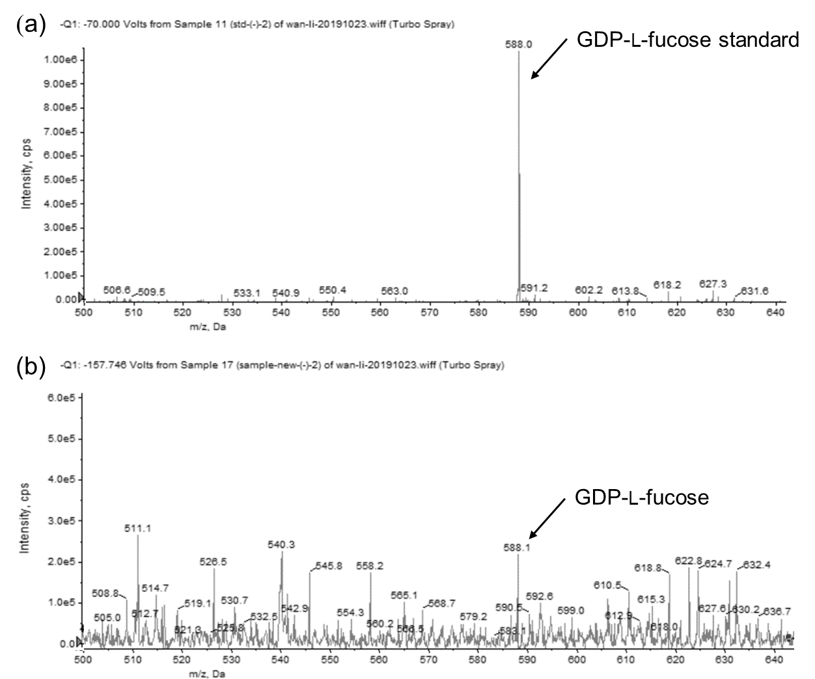
Figure S1 Analysis of GDP-L-fucose by ESI-MS. (a) GDP-L-fucose standard; (b) GDP-L-fucose from fermentation broth.

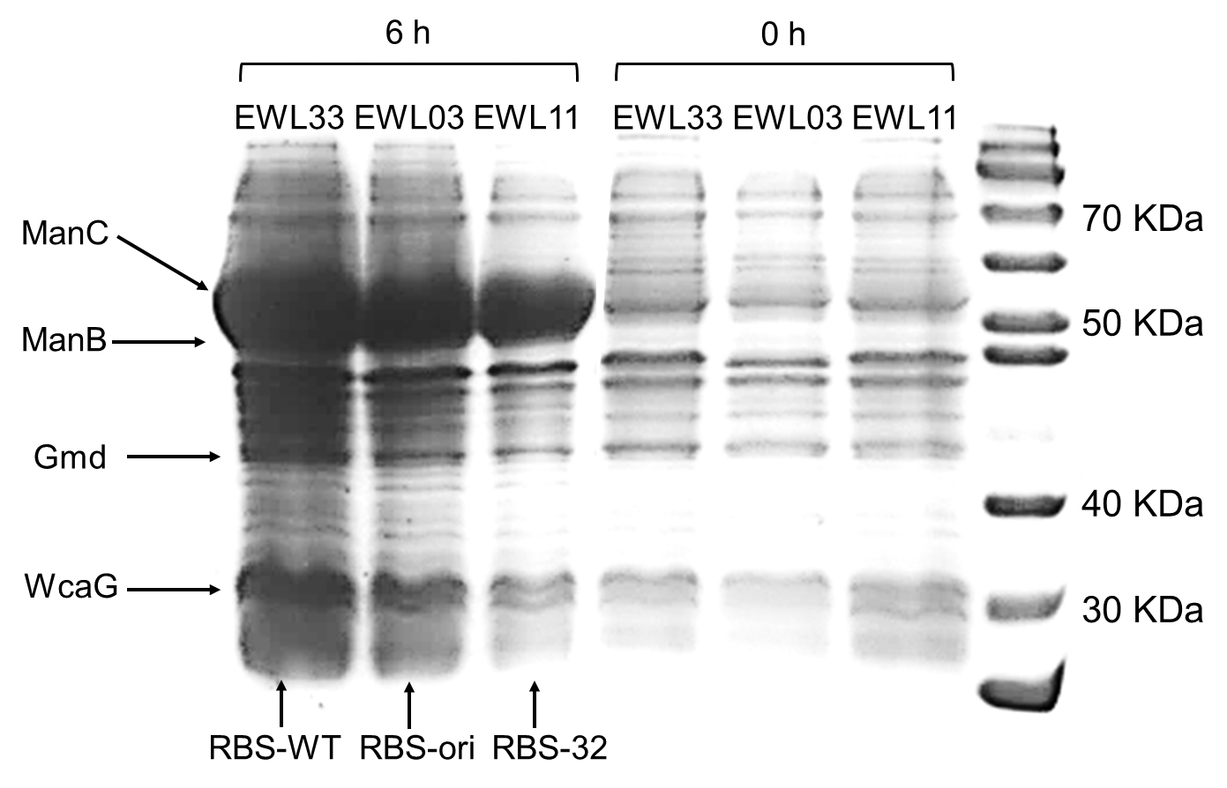
Figure S2 SDS-PAGE analysis of soluble fraction of different engineering strain.

